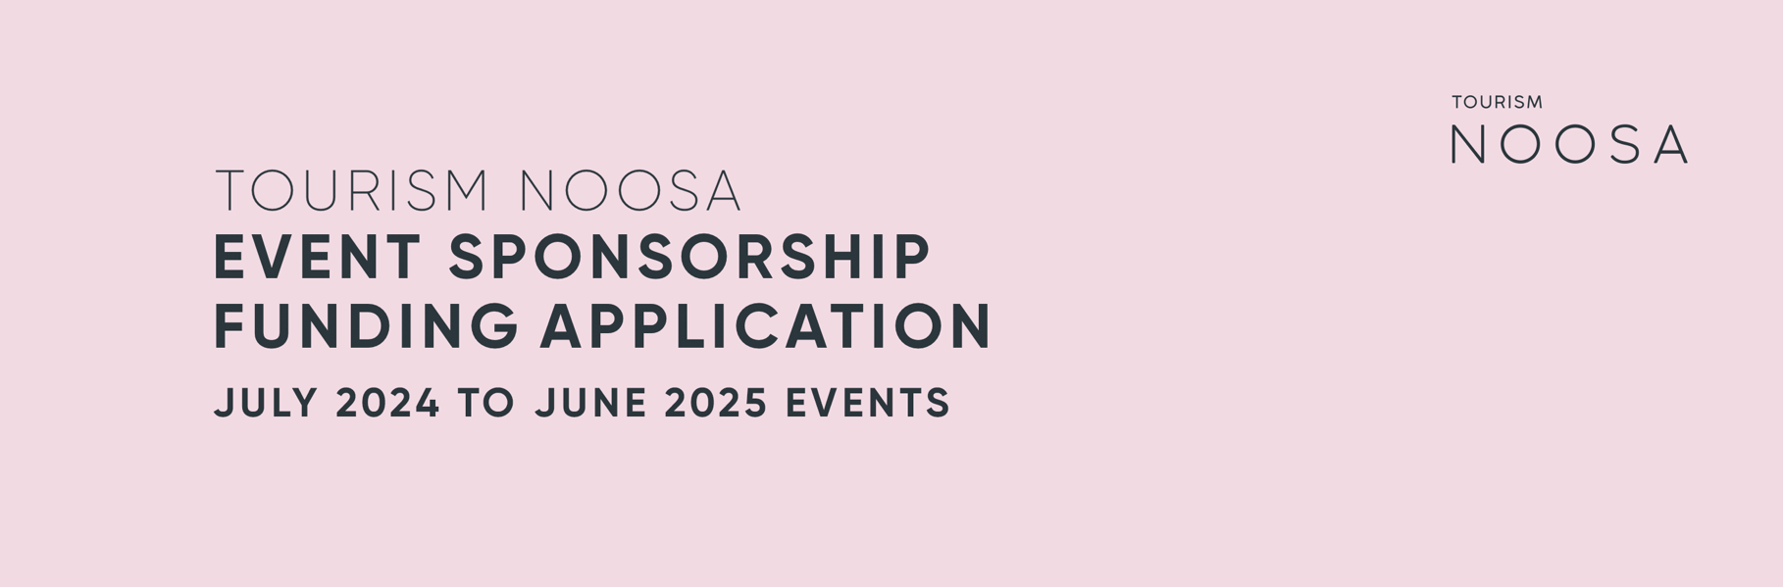

Application date:
Registered business name:
Trading as:
ABN/ACN:
Name of the event:
Date of event:
Registered business address:
Applicant name:
Mobile number:
Email:

- Please provide a brief description of your organisation, including its main objectives:

- Has your event or organisation previously received funding from Tourism Noosa?
- Is your event receiving funding from any other source?

- If yes, please state where from and the amount:

- Please outline your event management experience, or if you are a new event, provide any event-related references:

- Details of the location of the event:

- Event summary:

- Signature experience:

- Proposed timelines:

- Event outcomes:

- Event attendee numbers:

- Marketing goals and actions:
Marketing goal | Action/s

- Digital platforms:

- Sponsorship requested:
Marketing | $
Cash | $
Total requested funding | $

- Further notes that may support your application

- Please indicate the estimated number of event attendees and their origin where applicable:
Competitors:
i. | Primarily local/Sunshine Coast
ii. | Intrastate (Queensland)
iii. | Interstate market
iv. | International market
 | Total competitors

Additional attendees:
i. | Primarily local/Sunshine Coast
ii. | Intrastate (Queensland)
iii. | Interstate market
iv. | International market
 | Total of additional attendees

- Please attach an event budget for the event.

- Please attach your overall marketing plan for the event. This assists Tourism Noosa in marketing the event and the destination successfully. The plan is to include:
- Important dates
- Channels and platforms used
- Key messages
- Competition details

- Please list details of all permits, licenses, and insurances the event requires to run and if they have already been obtained:
Name of permit or license etc | Who from? | Obtained already?  Yes or No

- COVID-19 safe event planning
- Events are no longer required to operate under the COVID Safe Event Checklist. However, depending on the type of event and where it is being held, you may still be required to operate in accordance with a checklist – find out about the COVID Safe Checklists for Public Health and Social Measures linked to vaccination status requirements at above link.
- Please provide any available information regarding the economic impact of the event on the Noosa region. This may include but is not limited to:
- Direct visitor nights
- Visitors spend figures

Thank you for your July 2024 – June 2025 event application.
Please return via email to lee@tourismnoosa.com.au

