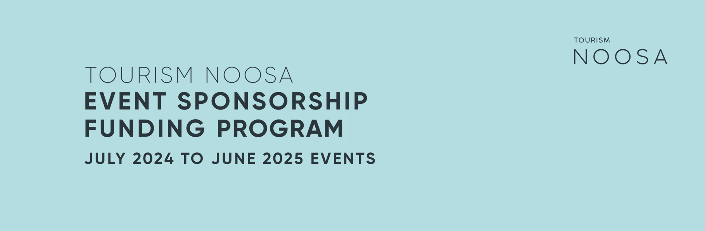

Tourism Noosa (TN) Event Funding applications for events held between 01 July 2024 and 30 June 2025 are now open with a closing date of Friday, 17 November 2023.

Aims and objectives of the event support program

Tourism Noosa takes an integrated destination management approach to marketing the Noosa region domestically and when appropriate internationally, and our activities are guided by the current Destination Noosa Strategy 2020-2023.

Tourism Noosa acknowledges that events can positively impact the regional economy and strengthen both the business and local community. Tourism Noosa is committed to building an iconic events calendar through targeted investment and adding, where possible, new events to encourage off-peak visitation and enable geographic dispersal.

Within that context, the aims and objectives of the Tourism Noosa Event Sponsorship Program are as follows:
- Generate local economic, environmental and social value in the Noosa region.
- Attract visitors when State and Australian border restrictions allow, to drive interstate and international visitation to the destination.
- Enhance the profile, appeal and visitation to the Noosa region's village communities.

Before completing your application, please read the Event Guidelines & Funding Assessment Criteria. Tourism Noosa will provide a Post Event Report and an opportunity to discuss the events sustainability objectives on approval of the Event Funding Application.

Please read all available information so you are familiar with these requirements prior to submitting your application. Tourism Noosa will provide a response on the application on or before 8 December 2023 (date subject to change).
If you have any queries regarding the application process, please contact
lee@tourismnoosa.com.au

Event guidelines and funding assessment criteria

Eligibility
Any event sponsored by Tourism Noosa must:
- Take place wholly within the Noosa region.
- Satisfy the regulatory requirements of existing COVID-19 safe event regulations, where applicable and relevant to the individual event, as determined by local, state and federal levels of government.
- All applicants should be a member of or be willing to become a member of Tourism Noosa.

Funding
The value of support offered by Tourism Noosa will be determined according to the events ability to satisfy the specific Event Funding Assessment Criteria outlined below. Event Sponsorship may comprise either/and/or cash and a non-cash marketing contribution.

Event Funding Assessment Criteria

Covid safety | Event organisers can successfully satisfy the relevant national, state and local government regulations associated with staging a COVID-safe event at the proposed time and obtain the appropriate permits, approvals and insurances.
Visitation | Event will target high-value travellers (participants and/or spectators), preferably from interstate and overseas, as border restrictions ease.
 | Events staged over two or more days that encourage overnight stays will be deemed more favourable.
 | Elements of the event have the potential to encourage geographic dispersal of visitors.
Sustainability | Event planning will include collaboration with the TN sustainability team to set and achieve agreed sustainability goals. These will be based on TN's Sustainable Event Criteria, which aims to lift event sustainability standards.
Marketing and brand alignment | Event is attractive to Noosa's target markets.
 | Event is aligned with Noosa's brand values.
 | There is suitable marketing lead time before the event.
 | A detailed marketing plan is provided to TN before the event.
 | Event organiser can provide TN with suitable event imagery and videos that showcase Noosa and the event.
Capacity to deliver | Event organiser has a proven record of staging successful events of the same nature.
 | Event organiser can provide on request relevant data on previously staged events as proof of capacity to deliver on criteria.
 | Event organiser will consider using local suppliers where possible.
Sound fiscal management | Event provides an accurate, detailed, forecasted event budget for the proposed event.
 | Sponsorship application provides a clear implementation plan.
Reporting | Event has systems in place to record data such as visitor numbers, visitor spend, and sustainability measures required for post-event reporting as part of the sponsorship agreement.
 | Event agrees to share with TN, in confidence, any relevant data collected on visitation and visitor spend that may aid TN in strategic objectives and forward planning.

Approval process
Particulars of the value of support offered will be issued to the applicant in writing in a
Letter of Offer from Tourism Noosa. Applicants will receive both an application received and an application assessment response via email. Event applications will be assessed by a panel
on or before Friday 1 December 2023 (subject to change).

